**Flexible Spending Accounts (FSA)**

According to healthcare.gov (<https://www.healthcare.gov/have-job-based-coverage/flexible-spending-accounts/)> if you have a health plan through a job, you can use a Flexible Spending Account (FSA) to pay for copayments, deductibles, some drugs, and some other health care costs. Using an FSA can reduce your taxes. FSA **allows an employee to put an amount into an account at the beginning of each year, up to $2,650, to be used only for health care expenses. This amount is not subject to federal income tax. If the amount in the FSA is more than the health care expenses (i.e. an “overage”), the difference is forfeit (lost). If the health care expenses are more than the amount (i.e. an “underage”), the employee must pay for the excess out of his/her own pocket. This excess payment can be claimed in an income tax return to receive tax credit at the rate of 25% of the excess payment.**

**You are a financial planning advisor working with a client. Assume that for this client their income is taxed at a 40% rate (combining federal, state, local tax see** [**https://taxfoundation.org/2018-tax-brackets/**](https://taxfoundation.org/2018-tax-brackets/) **and** [**https://taxfoundation.org/state-individual-income-tax-rates-brackets-2017/**](https://taxfoundation.org/state-individual-income-tax-rates-brackets-2017/) **).**

**Your client did not keep much data on health their care expenses. Their annual spending for the last 5 years was at least $1,000 and at most $3,000.**

This is the “data” which can be viewed either as estimates or set as a way to assess the clients risk tolerance. “The client would like to cover expenses of at least $1,000 and at most $3,000”.

If the client provided actual annual data you could use it to make sample estimates of expected annual spending based on some assumption on the distribution.

1. Explain if it is reasonable to assume that annual health care expenditure is Normally distributed even though we know it cannot be. Also, explain how you may determine estimates of mean and standard deviation and be confident they will be representative for this year’s expenditures. *You may argue technically and on characteristics of the health care expenditures. Consider using rank-order confidence intervals (*[*https://onlinecourses.science.psu.edu/stat414/node/316)*](https://onlinecourses.science.psu.edu/stat414/node/316)) *to estimate the population mean (e.g. we know that we can be 93.76% confident that the population median will be within the minimum and maximum observations).*

Need a representation of the uncertainty in annual medical spending mainly to compute likelihoods (i.e. probabilities/frequencies) about this year’s spending. Is the Normal distribution “good enough” a representation of the uncertainty in annual medical spending for the problem at hand?

Look at characteristics of Medical spending, compare with characteristics of Normal distribution. Where characteristics do not match, discuss how much this matters or can be alleviated.

Under this Normal assumption provided the clients lifestyle has remained the same, we can assume with 93.76% confidence that this year’s expenses will fall between $1,000 and $3,000. Since the mean and median are equal in a Normal distribution, this gives a confidence interval for the mean of [a,b] = [mu – z*sig, mu +z*sig] = [$1000, $3000],

93.76% confidence under Normal implies

Prob[&mu; - z*&sigma < X < &mu; + z*&sigma] = .9376

&alpha; = 1 - .9376 = .0624 significance (or outside the interval)

Equal both above and below interval so look at half significance on both sizes

Prob(X > &mu; + z*&sigma) = Prob(z > Z) = 1 - &alpha/2 = .9688

z = qnorm(.9688) = 1.863442751

mu = (a+b)/2 = $2000

sig = (b-a)/(2*z) = $536.6411

1. If your client puts in $2,650 (the maximum) into their FSA, how likely are they to use it all (and not lose or carry over unspent funds)?

If Q is the amount of expenses, then use it all if (Q>$2,650)

1. Suppose you want to have enough in the FSA account to cover all medical spending for a given year at least 95% of the time. How much should the client put in their FSA?

Want N so that Prob(Q < N) = .95

1. Suppose now you want to be sure 50% of time to spend all the funds. How much less than the maximum would the client put in their FSA? Is it better to put more or less than this amount in the FSA?

*Hint: Think about what is the marginal cost (or loss) for not having enough funds? That is, what is the loss per dollar when the there is an expense $1 more than in the account? This is the “underage cost” and note that it is the “opportunity” loss of not enjoying untaxed income you could have had if you had put $1 more in the account. Then think about what is the marginal cost (or loss) for having $1 mango in the account than needed? That is, what would you lose when there is an expense $1 less than what you put in the account? This is the “overage cost” and note that it is the “sunk” cost of putting funds in the account you lose at the end of the year. The client will suffer from having to “salvage” by deducting the expense off their taxes.*

Prob(Q < mu) = .5, so the difference form the max is $2,650 - $2,000 = $650 or about 24.5% less.

Look at the “marginal” cost for having $1 too much (“overage”)

Co = loss from forfeit – benefit of not paying tax of forfeit

Look at the marginal cost of not having $1 when needed (“underage”)

Cu = failure to benefit from FSA – benefit for medical tax deduction

Note that if the penalty for losing unused funds was the same as the benefit for using them, you would always put in the expected amount of expenses (mu). So when Co is not equal to Cu, what does suggest about putting more or less than mu in the account?

1. How much should your client put in their FSA to maximize benefit based on their (unknown) expected health care expenditures? For this amount, how often would they cover all of their medical expenses? (i.e customer service level or in-stock probability)?

*Hint: Graph the “expected” marginal overage (i.e. marginal overage times probability of overage) and similarly for underage as a function of the amount of funds put into the account. Use this to determine the amount to put in the account where you would not expect more from an overage than an underage (this is the so called “critical point”). Note that this is the amount that will maximize your clients expected benefit from having an FSA.*

Q* = optimal amount to put in

Look at marginal overage and underage as a function of amount Q in the FSA

O(Q) = Co when Q < N, 0 when Q >= Q*

U(Q) = Cu when Q > N, 0 when Q <= Q*

So the “expected” (or average) marginals are

E[O(Q)] = Prob(Q<N)*Co

E[U(Q)] = Prob(Q>N)*Cu

Use R to graph:

Q = seq(0:2650)

EO = pnorm(Q, mu;, sig)*.6

EU = (1-pnorm(Q, mu;, sig))*.15

plot(Q,EU,type="l",col=2)

lines(Q,EO)

Optimal when they cross which is about $1500 from looking at the graph. Setting the expected values equal, E[O(Q)] = E[U(Q)] and solving gives Prob(Q<N) will tell you the likelihood of spending less than the optimal Q*. Find Q* by looking at the inverse Normal that gives in probability

qnorm((.15/(.15+.6)),mu,sig)

Q* = 1548.351 or about $1548

1. What is the difference in expected overage/underage cost from putting in Q=$2,650 from the profit-optimizing amount Q* in Q5?

*Hint:* *By “expected” we mean “total average” given the uncertain demand. Keep in mind that by definition the expected overage/underage cost for putting in Q* is $0. If this requires a lot of computations, just indicate how it was done and the result you computed elsewhere.*

We need to consider the additional expected penalty for putting more than the optimal amount (where the expected penalty is 0). The overage penalty is more than the underage, so the marginal penalty for putting in Q > Q* dollars is E[O(Q)] – E[U(Q)]. We sum this from Q* up to $2,650 to account for the total expected penalty (technically it we should integrate, but this is good enough). The expected loss (EL):

EL = sum((EO-EU)*(Q>1345))

= 300.1586

Let’s check how good this estimate it by looking at the area under marginal expected loss:

pen <- function(x) {abs((1-pnorm(x, mu, sig))*.15 - pnorm(x, mu, sig)*.6)}

plot(Q, pen(Q))

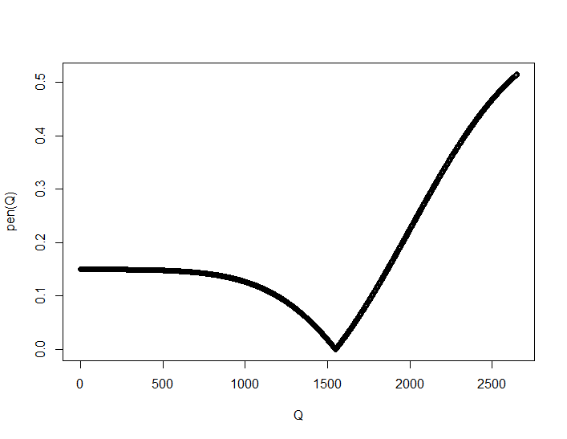

integrate(pen, 1548,2650)

299.3853 with absolute error < 3.3e-12

That’s really close! So this is a good double check.

What’s more important is the “sensitivity” of Q*. We want to get an idea of how accurate we have to be and also how far off from Q* we can be before we start to lose significantly. The easiest thing to do here is just graph the penalty function (the integral or area under the

Qs = 1548

penalty <- function(x) {if(x>Qs) sum((EO-EU)*((Q>Qs) & (Q<x))) else sum((EU-EO)*((Q<Qs) & (Q>x))) }

z <- penalty(0)

for(q in seq(1:2650)) { z <- c(z, penalty(q)) }

plot(seq(0:2650), z)

Could also use integral function:

penalty <- function(x) {if(x>Qs) integrate(pen, Qs, x)$value else integrate(pen, x, Qs)$value }

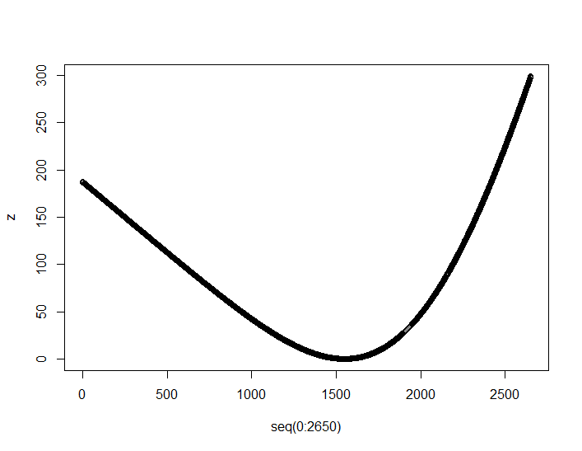

So basically it looks like the Q* could be off by as much as $250 and we would lose less than $25 for the error.

1. FSA rules allow up to $500 not used in one year to be carried over (rather than lost) into a following years FSA account. How does this affect the optimal amount to put into your clients FSA account? What is the value of this carry-over benefit?

This will effectively reduce the marginal overage penalty Co by some amount B as you now can have a surplus of up to $500 without losing it. Underage penalty Cu will remain the same. Since there is no risk for this amount, you would want to add this to the optimal quantity $Q* which effectively increases the frequency of covering all expenses. Thus the new optimal quantity is Q* + $500 giving a frequency of coverage of Prob(Q < Q* + $500)

This will be the new “critical value” which you can now use so solve for the overage carryover benefit B

Prob(Q < Q* + $500) = Cu/(Cu + Co – B)